## Mock App Listing

Title – Holiday Finder

Short Description – A small app for finding that perfect holiday destination using Flickr.

Long description – This app allows people to get a real view of a holiday destination through the cameras of people living there. Using Flickr’s Photo Database this app allows people to see a real time view of the scenery around a specific location. This will in turn give the user a better feel for the destination and hopefully persuade them to have a holiday there.

Screen Shots –

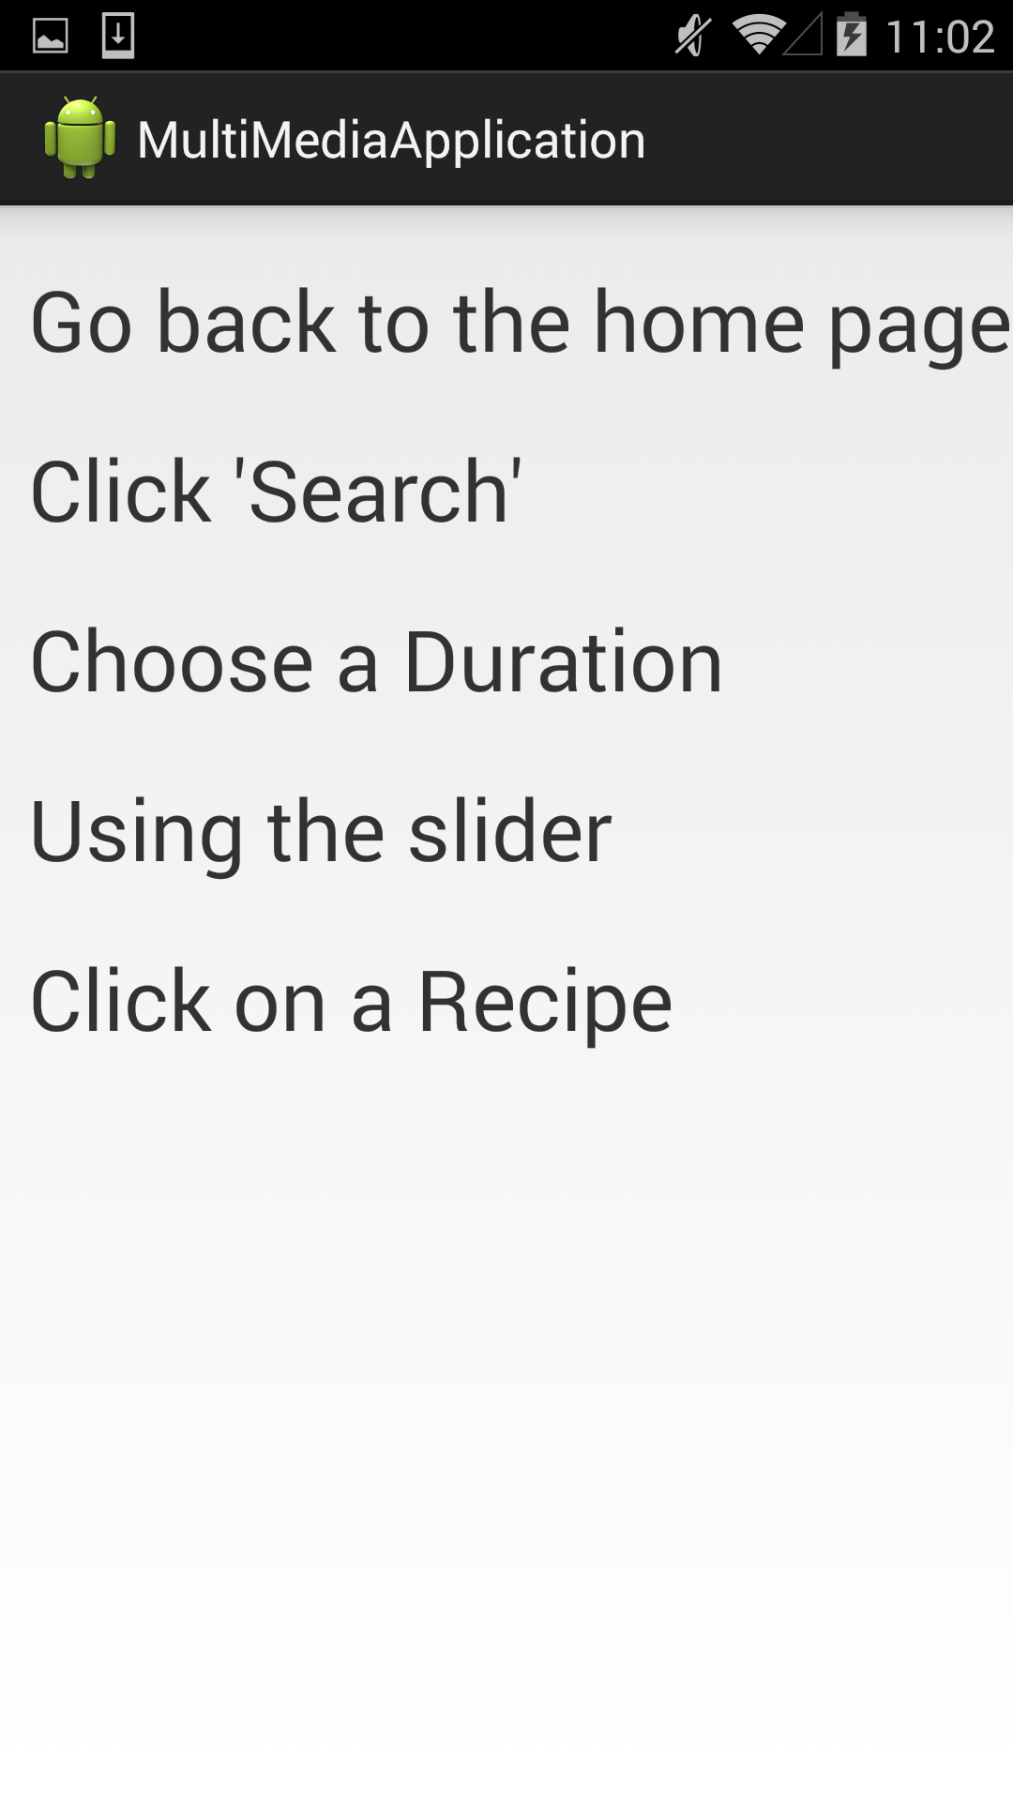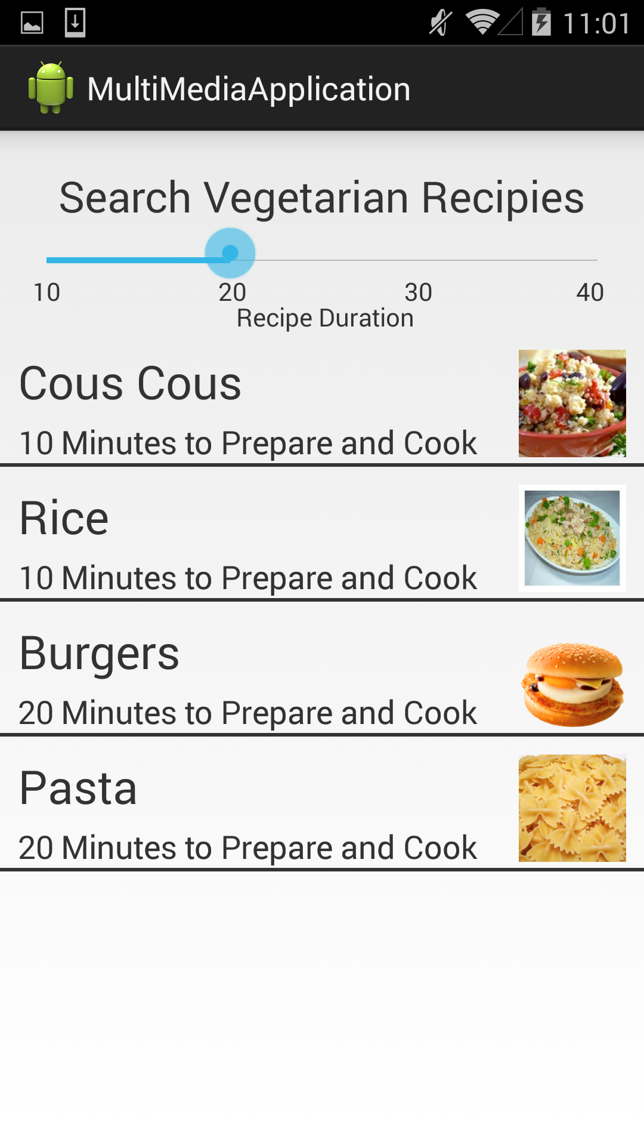

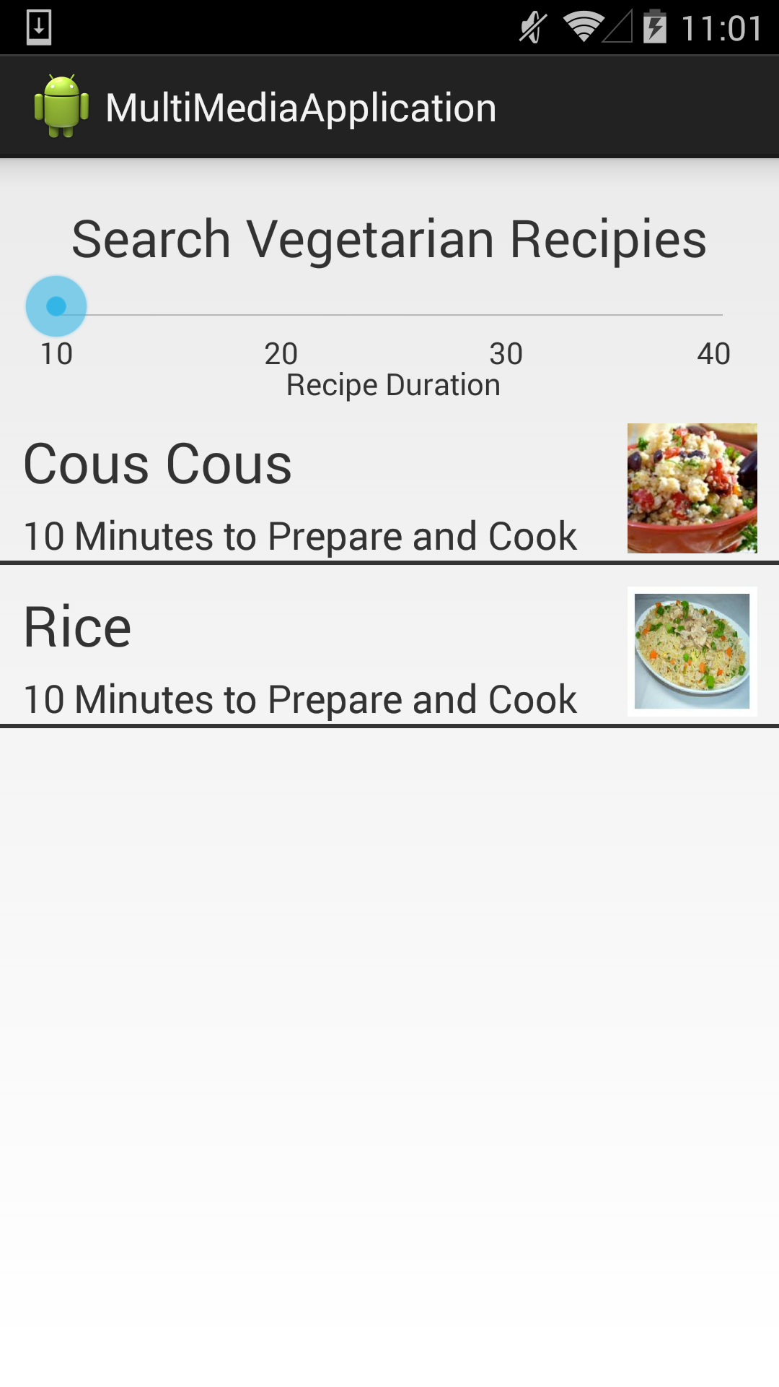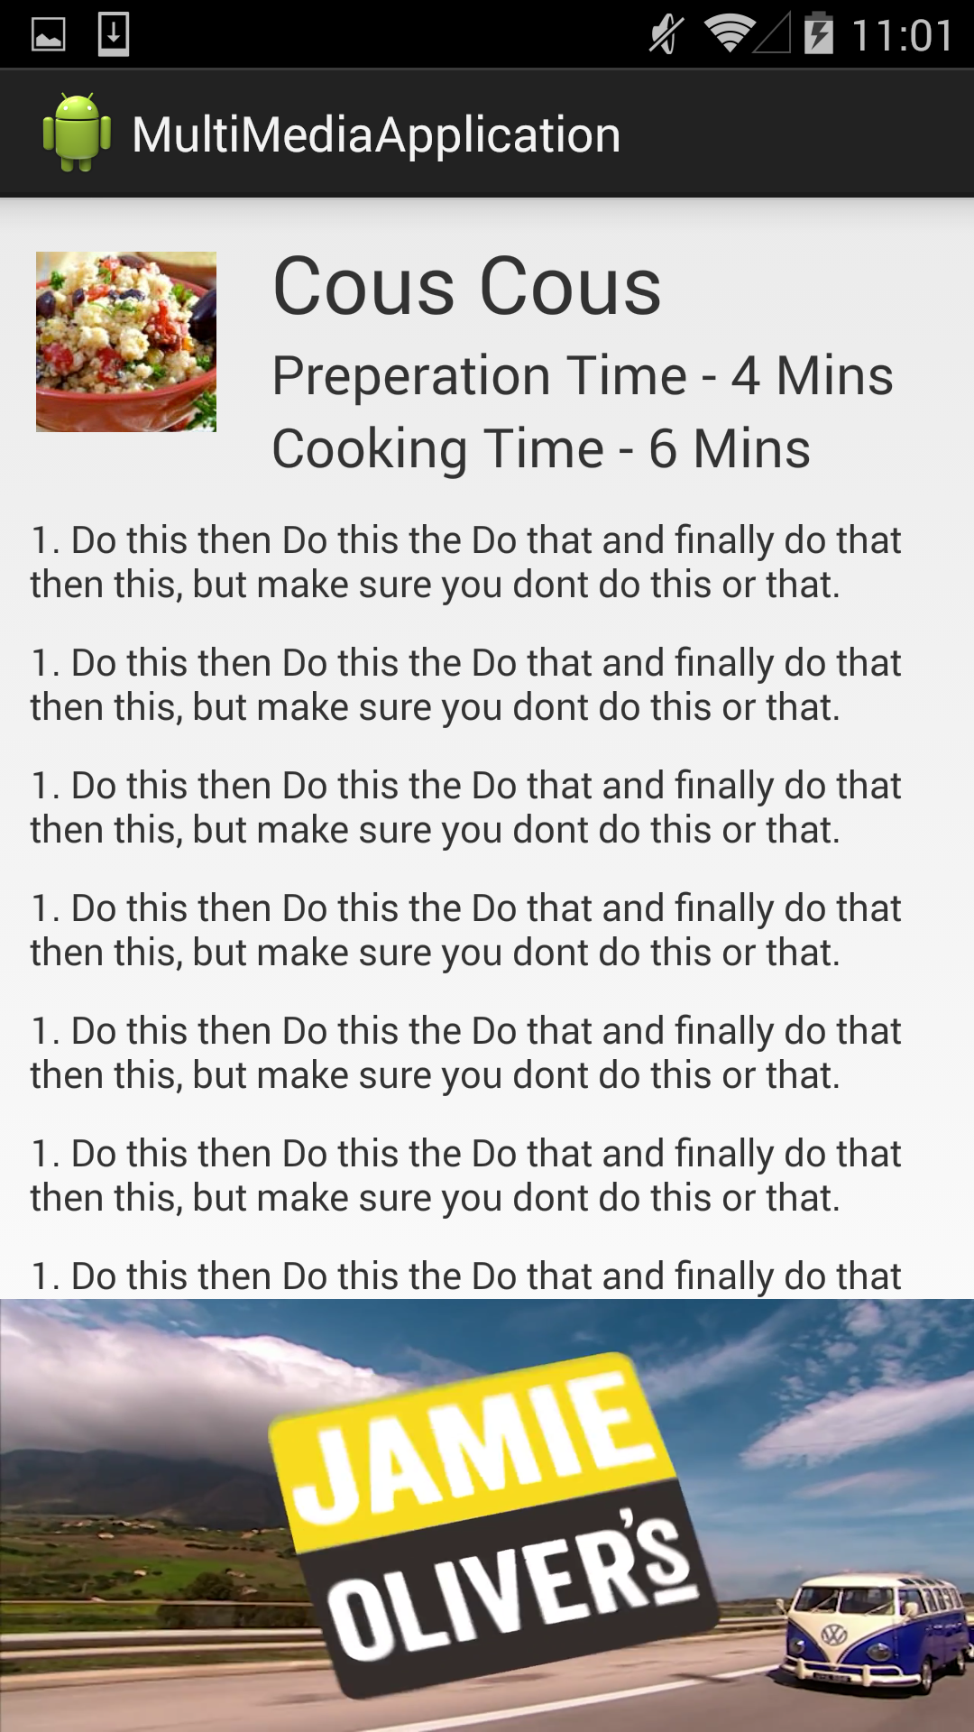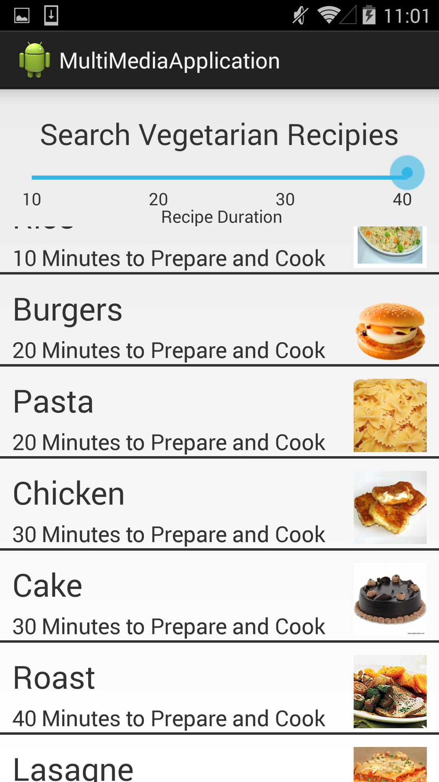

## What I Learned

This unit was my first time at tackling the java programming language and although I have previous experience in C++ and in visual basic but I have not tried to code in java before this unit. I have always wanted to try and build an app for my phone but I never knew where to start. This unit gave me the knowledge of not just how to build an app and how to code in java but the programs to use and the ways to test programs. It also allowed me to practice my HCI when designing the app. The last main thing that I learned from this unit is that although I think that I am planning the application well I still need to add more.

## What I’m Proud of

The main part of this unit that I am proud of is that I did not have to ask for help as often as I thought that I would need to. I though at the start of this unit that I would have to ask either other students for help or ask the lecturer for help quite often but as it turns out I did not have to ask that often and even sometimes I lent my help to some of my fellow classmates.

## Improvements

I would change the way that it loads the images, I would like to add a way so that it only loads the first 20 images that it finds on Flickr and then as the user scrolls it will count how many images it has scrolled past and load that many of new ones. It could then unload the images at the top of the page and cache them ready for reloading when the user scrolls back up or reloads the page.

## Additional Features

If I was going to continue to develop this app there is one major feature that I would want to implement. This is the ability to swipe right on the screen showing a city and get updating news feeds on that city. This would allow people to look at the photos of and around a city but also have a change to see what is going on in that city at the time. This would turn the app from a fun Flickr viewer into a really informative holiday destination app.

## Mobile Devices vs. PCs

On mobile devices you can use the mobile data and gps to get the exact location of the mobile device. This is something that you cant really do with a pc due to the pc not being a mobile device. The location aspect of any app works better when the device is able to move around.

There is also a lot that the pc can do that mobile devices cant do. The main feature is that they can be upgraded. With a PC you have the option to change anything that does not work or that you don’t like. With a mobile device you are stuck with the hardware that comes with the device. A PC has the option to change the screen for a better or bigger one, you can change the hardware to make it quicker or add certain features to it. A good example is if you want to have surround sound then on a PC you can buy a sound card to give you this option. With a mobile device, if it does not come with surround sound by default then you will not be able to get it.